# **Greenbelt Reparations Project Summary**

### **Project Definition**

The goal of this project is to analyze and visually present demographic changes in Greenbelt over the past four decades. This work will support the organization’s efforts to recognize and address the historical impact of racial disparities on African American and Native American communities. This research will help the commission develop informed recommendations for reparations policies.

### **Expected Deliverables**.

* Maps of Demographic Changes – We’ll create GIS-based maps that show how different parts of Greenbelt have changed over time.
* Historical Context Analysis – A report summarizing key historical demographic trends and their significance.
* A Summary Report – This will explain the key patterns we find in the data and why they matter.
* An Interactive Visualization – A way for people to explore the data themselves.

## **Technical Needs**

* Census and Education Data – This data is mainly from Census.gov and the Maryland Department of Education.
* GIS Mapping Tools – Like ArcGIS, to create visual maps of demographic shifts.
* Data Analysis Software – Potentially Tableau or GitHub for organizing and analyzing the data.

**Key Risks & Mitigation Strategies**

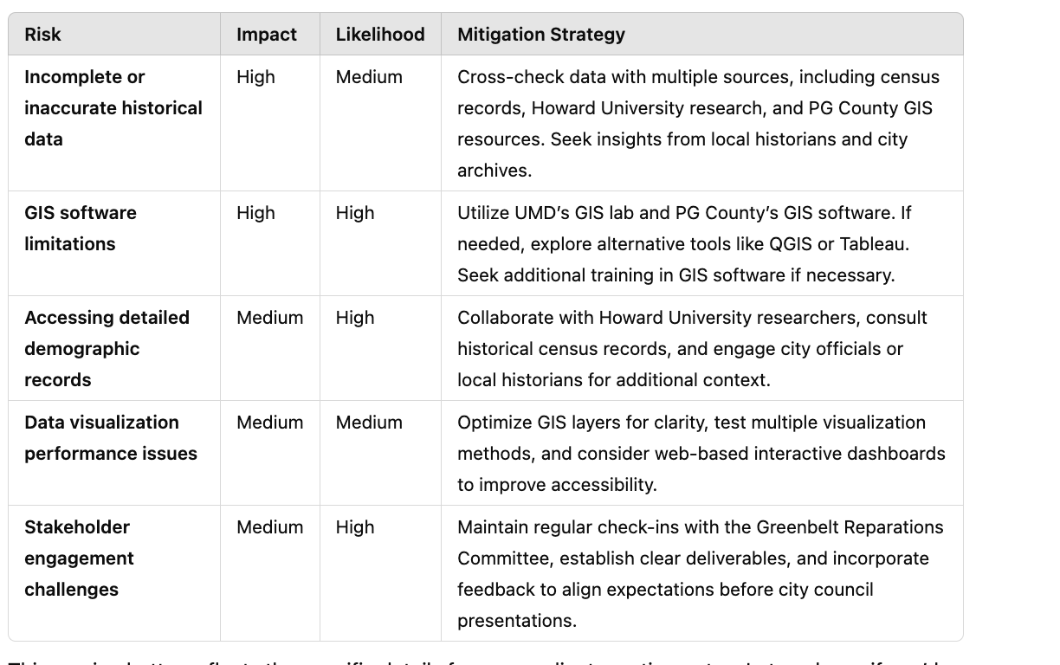

## **Challenges & How We’ll Handle Them**

### Finding complete and accurate historical data → We’ll cross-check sources and ask faculty for guidance.

### Using GIS software effectively → If needed, we’ll explore alternative tools or get extra training.

### Making sure our visuals are clear and useful → We’ll test different ways of presenting the data and get feedback.

### Getting enough input from stakeholders → We’ll stay in close contact with the organization to align expectations.